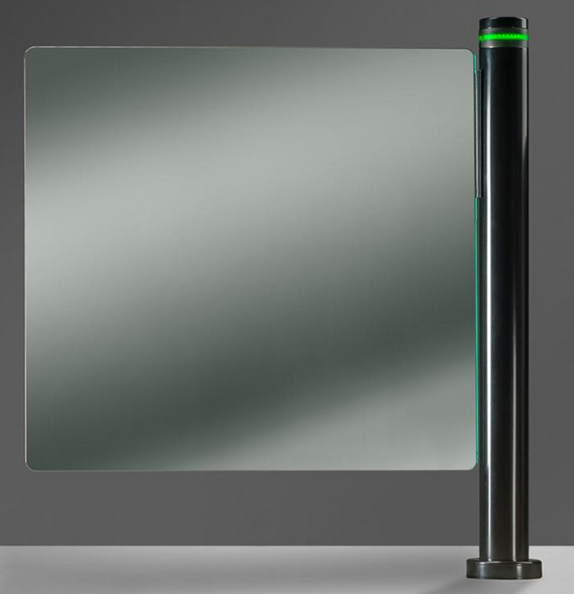

ARCHITECTURAL SPECIFICATION WINGLOCK SWING

SECURITY OPTICAL TURNSTILE GATE

Contents

Security Optical Turnstile Section 11-14-00 Pedestrian Control Equipment (Gates/Turnstiles) 2

Part I General 2

1.01 Section Includes 2

1.02 RELATED SECTIONS 2

1.03 REFERENCES 2

1.04 QUALITY ASSURANCE 2

1.05 SUBMITTALS 2

1.06 DELIVERY, STORAGE AND HANDLING 3

1.07 PROJECT/SITE CONDITIONS 3

1.08 WARRANTY 3

PART II – PRODUCTS 3

2.01 MANUFACTURER 3

2.02 PRODUCT 3

2.03 TURNSTILE GATE CONSTRUCTION 3

2.04 EQUIPMENT 3

2.05 Communication System. 3

2.06 SECURITY EQUIPMENT 4

2.07 SAFETY SYSTEM 4

2.08 ACCESS CONTROL AND FIRE ALARM INTEGRATION 4

2.09 SEQUENCE OF OPERATION 4

2.10 PERFORMANCE/THROUGHPUT 5

2.11 HARDWARE/MATERIALS 5

2.12 FINISH 5

2.13 ADDITIONAL OPTIONS 5

PART III – EXECUTION 6

3.01 INSTALLATION 6



# Security Optical Turnstile Section 11-14-00 Pedestrian Control Equipment (Gates/Turnstiles)

## Part I General

### 1.01 Section Includes

1. This section covers the furnishing and installation of a complete Security Optical Turnstile Gate. Provides complete system that has been fabricated, assembled, and tested for proper operation at the factory.
2. It includes barrier glass, motor columns with drive system, hardware, cabling, self-diagnostics tool, as required for installation.

### 1.02 RELATED SECTIONS

1. Section 09600 - Flooring
2. Section 16123 - Electrical Supply and Termination
3. Section 11 14 – Pedestrian Control Equipment
4. Section 11-14.13.19 – Turnstiles
5. Section 11-14.53 – Pedestrian Security Equipment

### 1.03 REFERENCES

1. ANSI Z97.1 - American National Standard for Safety Glazing Materials used in Buildings.
2. AAMA 2604 - Voluntary specification, Performance Requirements and Test Procedures for High Performance Organic Coatings on Aluminum Extrusions and Panels.
3. AAMA 2605 - Voluntary Specification, Performance Requirements and Test Procedures for Superior Performing Organic Coatings on Aluminum Extrusions and Panels.
4. ASTM A 480/A 480M - Standard Specification for General Requirements for Flat-Rolled Stainless and Heat-Resisting Steel Plate, Sheet, and Strip.
5. ASTM B 209 - Standard Specification for Aluminum and Aluminum-Alloy Sheet and Plate.
6. ASTM B 221 - Standard Specification for Aluminum and Aluminum-Alloy Extruded Bars, Rods, Wire, Profiles, and Tubes.

### 1.04 QUALITY ASSURANCE

1. Manufacturer shall be a company specializing in the supply of security optical turnstiles with a minimum of 10 years’ experience.
2. Manufacturer shall supply a factory-trained supervisor during installation of the security optical turnstile.
3. Manufacturer must provide for a local, factory-trained, field service technician to competently service the security optical turnstile; and to provide for the local support of the customer’s service technicians, in the event that the customer's trained technician is not available.

### 1.05 SUBMITTALS

1. Submit project specific shop drawings, finish samples and Operating & Maintenance Manuals.
2. Indicate pertinent dimensions, general construction, component connections and locations, anchorage methods and locations, hardware, and installation details.

### 1.06 DELIVERY, STORAGE AND HANDLING

1. Deliver materials to job site in manufacturer’s packaging undamaged, complete with installation instructions.
2. Store off ground, under covered area, protected from weather and construction activities.

### 1.07 PROJECT/SITE CONDITIONS

1. The Winglock Swing Security Optical Turnstile Gate installs on finished floor only.
2. Floor must be complete with conduit supplied to meet manufacturer’s specified drawings.

### 1.08 WARRANTY

Boon Edam warranties its products against defects in material and workmanship for a period of twelve (12) months from the date of shipment of the product. This warranty excludes glass breakage, normal wear on finishes or damage that occurs due to abuse, misuse or acts of God.

## PART II – PRODUCTS

### 2.01 MANUFACTURER

Boon Edam, Inc., 402 McKinney Parkway, Lillington, NC 27546.

(910) 814-3800 Fax: (910) 814-3899 Homepage: [www.boonedam.us](http://www.boonedam.us)

### 2.02 PRODUCT

Boon Edam Winglock Swing Security Optical Turnstile Gate models:

Winglock Swing includes stainless steel column with swinging glass panels.

### 2.03 TURNSTILE GATE CONSTRUCTION

1. **Glass Panel**: Barrier panel to be manufactured with flat, clear tempered safety glass. (**10mm thickness)**
2. **Motor Column covers**: Anodized, Powdercoated Stainless Steel, or Stainless Steel.
3. **Control system**: Microprocessor controlled Closed Area.

### 2.04 EQUIPMENT

1. **Drive System**: Electromechanical drive system specially designed for the Winglock Swing mounted inside the column together with all of the controls. The drive system may allow for bi-directional or one way traffic. (Requires 110-240 VAC, 1 Phase, 15A service from below)
2. **Locking Device**: The locking device is an electromagnetic brake activated in the closed position and will withstand up to 120Nm pushing force.
3. **Power Loss**: In the event of power loss, the Winglock Swing barriers can open manually for egress.
4. **Controls**: Factory installed, purpose built microcontroller platform with embedded custom software.

### 2.05 Communication System.

* 1. Authorized entry method, the Winglock Swing shall signal the user when the unit receives the authorized access signal from the access control system.
  2. The Winglock Swing shall visually signal the authorized user to enter.
  3. The visual signal will be an LED strip on the top of the column. In addition, a visual violation LED signal will be activated if there is a malfunction or locked.

1. **Security Reporting:** The Winglock Swing must have the capability of providing security violation alerts to the access control system or an on-site remote panel (not supplied by Boon Edam).
2. **Inputs**: Seven configurable inputs are available.
3. **Outputs**: Six configurable outputs are available in a Normally Open state.
4. **Standard inputs include**: **Standard outputs include**:

Input 1: Pulse to Non-Secure (Out) Output 1: Malfunction Alarm

Input 2: Not Used Output 2: Door Closed

Input 3: Pulse to secure (In) Output 3: Return to Secure

Input 4: Fire Alarm Output 4: Return to Non-Secure

### 2.06 SECURITY EQUIPMENT

1. **Actuation**: Barrier actuation by card reader mounted on top of column or remotely. (Not supplied by Boon Edam)
2. **Actuation Device**: Although tied into the turnstile, actuation devices are provided by the Access Control Integrator.
3. **Inputs and Outputs**: The control module includes a series of inputs and outputs which can be selected for optimal use:
4. Inputs: three inputs are available. Specific inputs will be configured as listed in Section 2.05 D. Along with Fire Alarm Integration.
5. Outputs: Four outputs are available as Normally Open. Specific outputs are configured as listed in Section 2.05 D.
6. Service Tool Software: PC software allowing connection to the control system allows the following:
   1. Upload and download software and configuration capabilities.
   2. Setting of times.
   3. Monitoring and troubleshooting matrices.
   4. Maintenance tracking
   5. Comma Seprated Values (CSV) event log file reporting system for service, maintenance and configuration tracking methods.

### 2.07 SAFETY SYSTEM

1. **Torque:** A preset parameter within the programming of the drive system provides rotation force to be minimized, allowing the doorset to be stopped manually by applying pressure against it’s rotation.

### 2.08 ACCESS CONTROL AND FIRE ALARM INTEGRATION

A. The Winglock Swing must be capable of integrating with the Access Control System (ACS) and Fire Alarm System via a series of dry contact potential free input signals. Control wiring from the ACS system are to be connected (integrated) to the turnstile via an I/O board, or terminal strip, supplied within the turnstile control system (ACS cabling supplied by others).

1. **Fire Alarm**: Each master column must have it’s own dedicated fire alarm relay signal, normally closed contact (opens on active alarm), dry contact circut. Winglock Swing can be programmed to open in desired direction – toward non-secure (egress) or toward secure side. All LED’s will illuminate green. Once alarm is reset lanes will resume normal operation. Fire alarm overrides all other functions.

### SEQUENCE OF OPERATION

A. **Authorization, Pulse to Secure:** Authorization from the Access Control System (ACS) or remote panel button is required before the unit will open. After valid authorization the LED pathway lights will indicate authorization has been granted. The glass panels will also Swing open to allow directional passage.

B After authorized passage, the return pulse to secure will provide a signal to the ACS indicating the user has passed through the lane. This provides anti-passback and mustering capabilities.

1. **Fire/Life Safety**: All authorized life-safety and emergency alarm contacts must drop signal to automatically open the glass gates to the open exiting position.
2. **Authorization, Pulse to Non-Secure**: Identical to the “Authorize In” sequence of operation above.
3. **Fire/Life Safety**: All authorized life safety and emergency contacts must drop signal to automatically open the glass gates to the open exiting position. Life safety overrides all other functions.
4. **Power Loss:** Upon power loss, the units are fail-safe standard.

### 2.10 PERFORMANCE/THROUGHPUT

The Winglock Swing can provide two-way traffic, one-way traffic, or a blocked barrier (closed entry/exit). Throughput is defined as the number of people per minute which can pass through an optical turnstile in *one direction only*. The average throughput of the Winglock Swing is aproximately 6 - 8 people per minute.

### 2.11 HARDWARE/MATERIALS

1. **Sheet Metal:**  All sheet metal shall be 304 #4 brushed stainless steel or powdercoated steel.
2. **Safety Glass**: All barrier glass shall be 10mm clear safety glass.
3. **Plate Aluminum:** All plate aluminum shall be 6mm 1050-H24 or equivalent plate.
4. **Hardware:** All hardware to be metric thread to conform to ISO or DIN standard.
5. **Plastics:**  Dark Grey IR Polycarbonate.

### 2.12 FINISH

The following finishes are available for the removable panels, bottom plinth covers, face and top cover plate.

1. **Painted Coatings**
2. AAMA 2605 Superior Performing Organic Coatings (e.g.: Duranar, Fluropon; 70% Kynar Fluoropolymers).
3. AAMA 2604 High Performance Organic Coatings (e.g.: Powder Coating).
4. **Stainless Steel Clad Type 304**
5. #4 Brushed Satin
6. #8 Highly Polished (mirror finish) – Slide bottom center plinths only.
7. **Powdercoat**
8. Tiger #059/80106 10% Gloss
9. RAL 9005 gloss 80%

### 2.13 ADDITIONAL OPTIONS

The following are additional features and options available with the Lifeline Swing.

1. Lifeline Boost - pedestal for separate access control authorization device outside of cabinet.
2. BoonTouch remote control panel.
3. Push to Release – doors will release with nominal direct pressure.

## PART III – EXECUTION

### 3.01 INSTALLATION

1. **Inspection:** Installer must examine the location and advise the Contractor of any site conditions unacceptable for proper installation of product. The minimum conditions necessary to initiate installation are:
   1. Floor must be dead level at any point within the footprint of the door.
   2. Finished floor must be installed.
   3. Floor must be complete with conduit supplied to meet manufacturer’s specified drawings.
   4. Power supply (110-240VAC) must be installed. Power and comunication come from the floor to the secure side of the cabinet as per approved specified drawings.
2. **Erection:** Install turnstile in accordance with manufacturer’s printed instructions. Set units level, plumb, and with uniform hairline joints. Anchor securely into place. Use only factory trained installers.
3. **Adjustment:** Installer shall adjust turnstile for smooth operation and proper performance.
4. **Instruction:** A factory-trained installer shall demonstrate to the owner’s maintenance crew the proper operation of the Winglock Swing Security Optical Turnstile Gate and the necessary service requirements such as lubrication, cleaning, and inspection of components upon completion of installation.
5. **Cleaning:** Clean metal and glass surfaces carefully after installation to remove excess caulk, dirt and labels.

**Boon Edam, Inc. reserves the right to change this specification at any time without notice.**